Simulation Documentation

Simulation 1: Step Response Experiments
For Demo 1, four step response experiments were carried out. A step response experiment was done for each motor, for the robot as a system moving forward, and for the robot as a system rotating. These experiments were done to determine the best models for different aspects of the robot’s behavior. The models were needed to properly tune the PID controllers used to drive and control the robot.

Left Motor Step Experiment
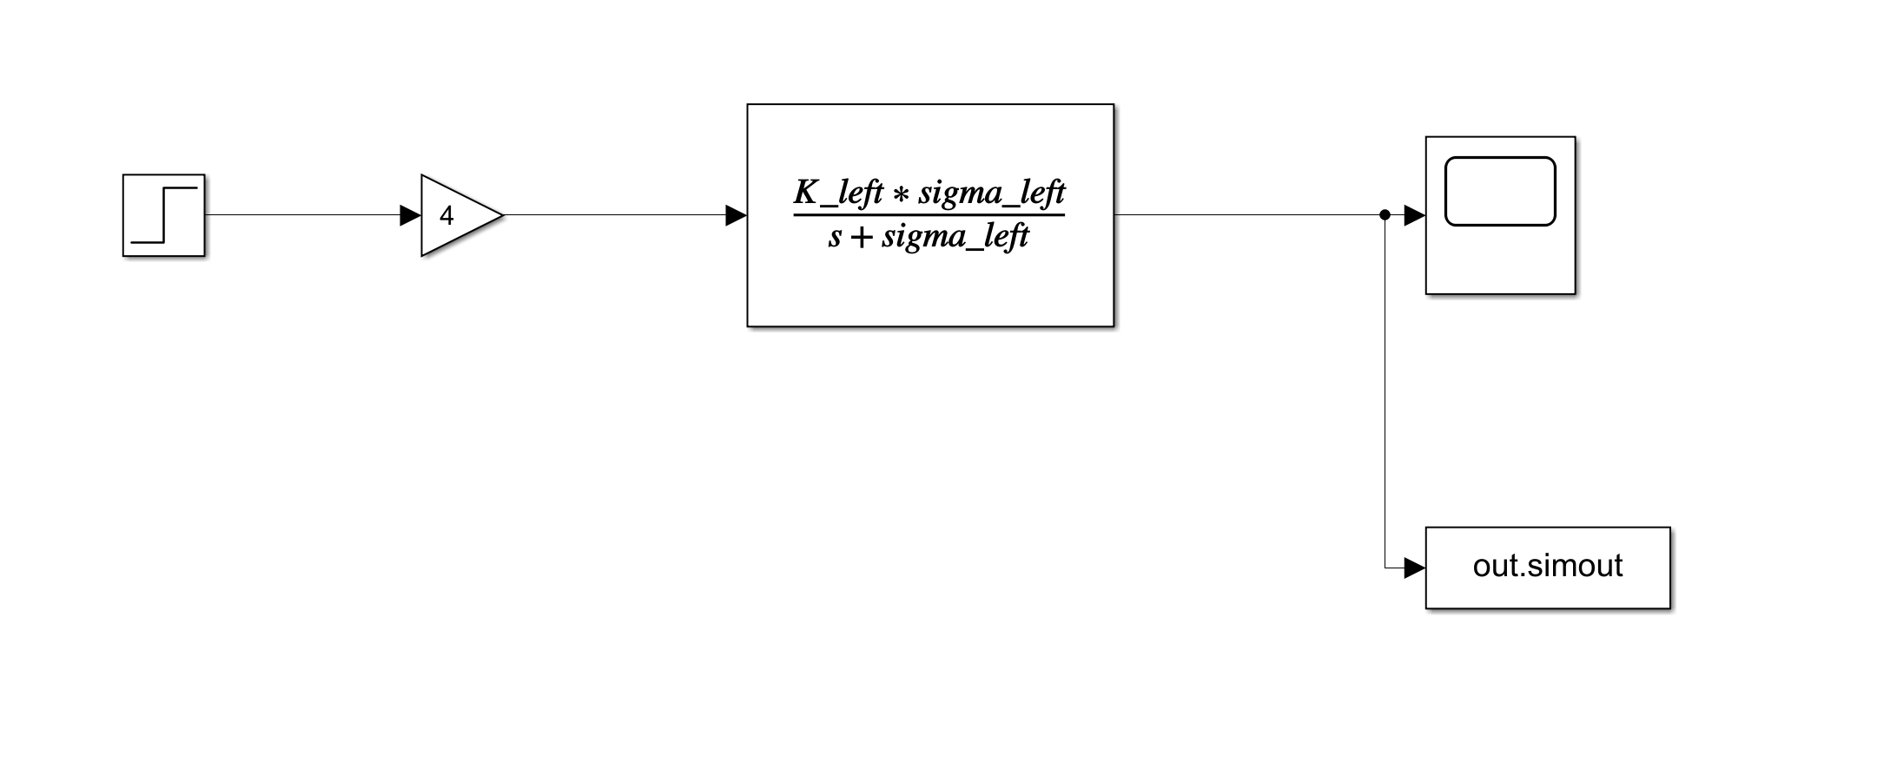
Figure 1: leftMotorStepResponse.slx
For the left motor step experiment, the robot was driven forward for 1.8 seconds while the left wheel’s angular velocity was sampled and printed to serial. In the MATLAB script stepExperimentInitialize.m, the experimental data was plotted against the simulation output in leftMotorStepResponse.slx. The model variables in Simulink were tuned to fit the experimental data. The fitted simulated response and experimental response are shown in the following figure, Figure 2.
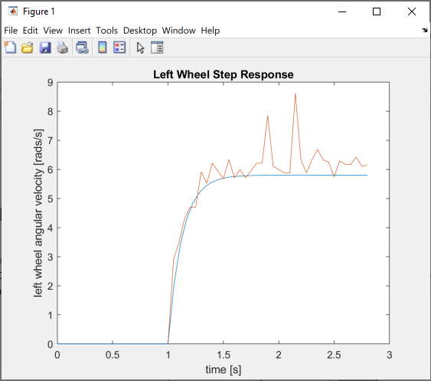
Figure 2: Left Wheel Step Response Results – Simulated and Experimental
Right Motor Step Experiment
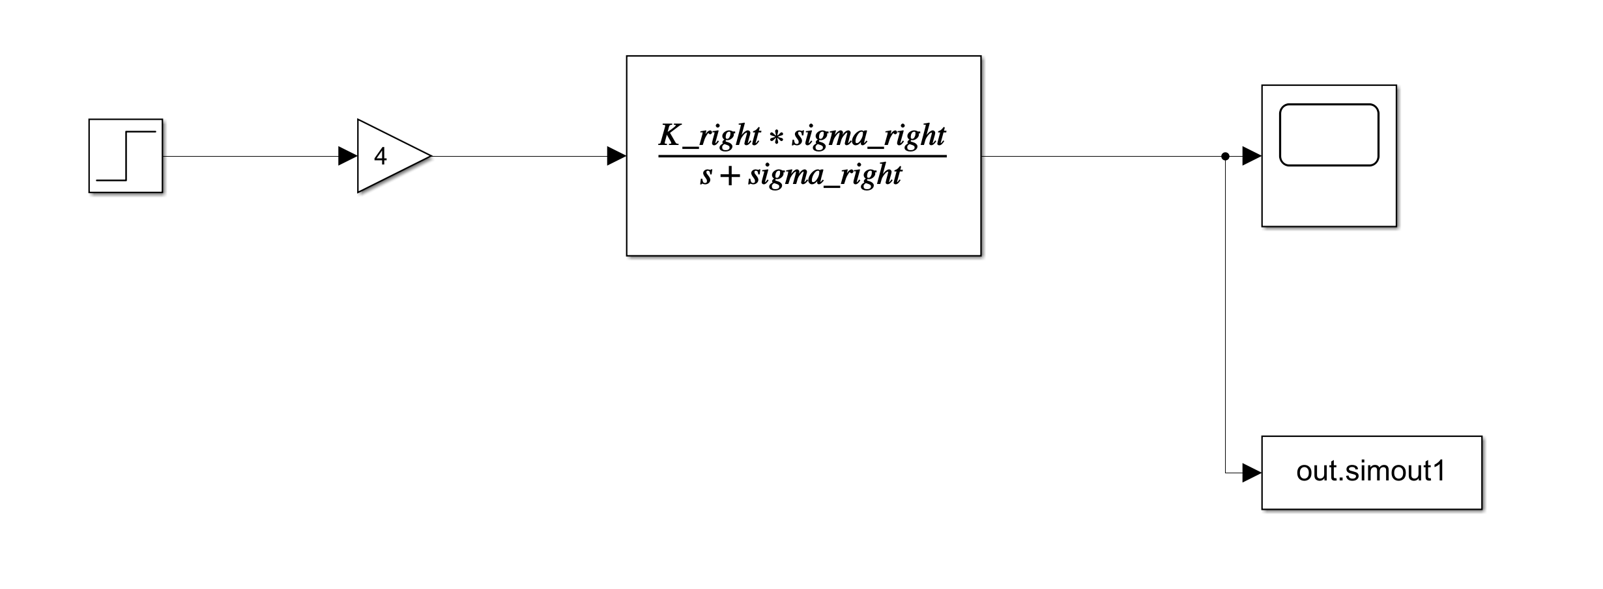
Figure 3: rightMotorStepResponse.slx
The same process used in the left motor step experiment was used in the right motor step experiment. Simulation output was matched to experimental data. The experimental and simulated responses are shown in the figure below in Figure 4.
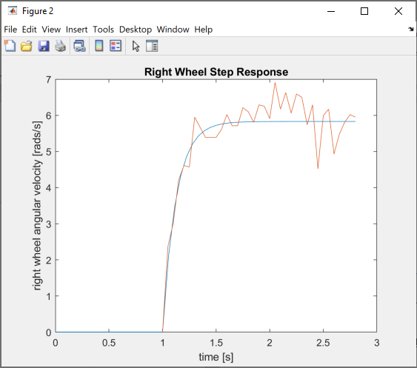
Figure 4: Right Wheel Step Response Results – Simulated and Experimental
Robot Forward Step Experiment
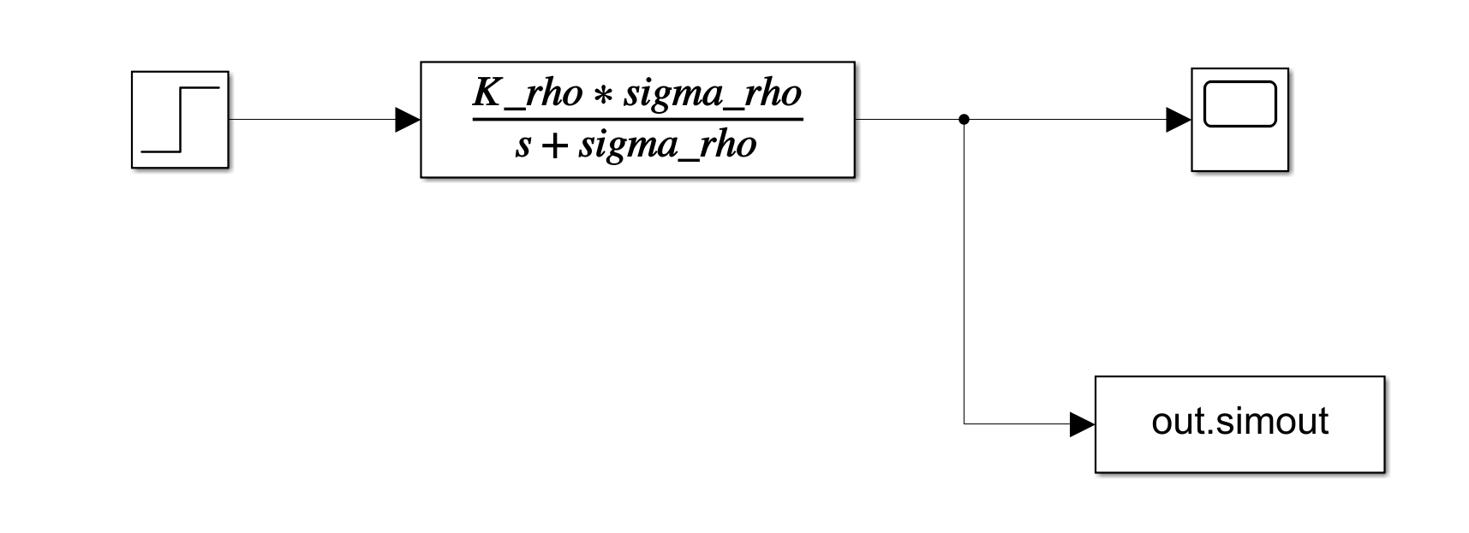
Figure 5: fullRobotForward.slx
In the forward motion step response experiment, equal voltages were supplied to each motor to drive the robot straight forward, and the robot’s velocity in the x direction was monitored. The MATLAB script stepExperimentInitialize.m was again used to plot simulation data against experimental data. The fitted simulation data and experimental data are shown in the figure below in Figure 6.
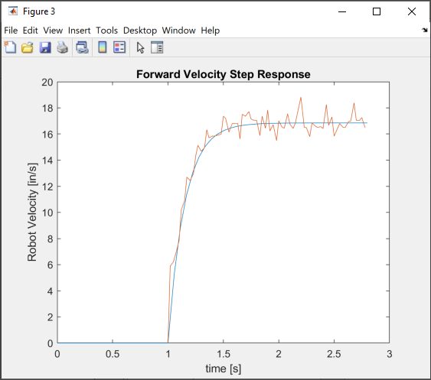
Figure 6: Forward Velocity Step Response Results – Simulated and Experimental

Robot Rotational Step Experiment
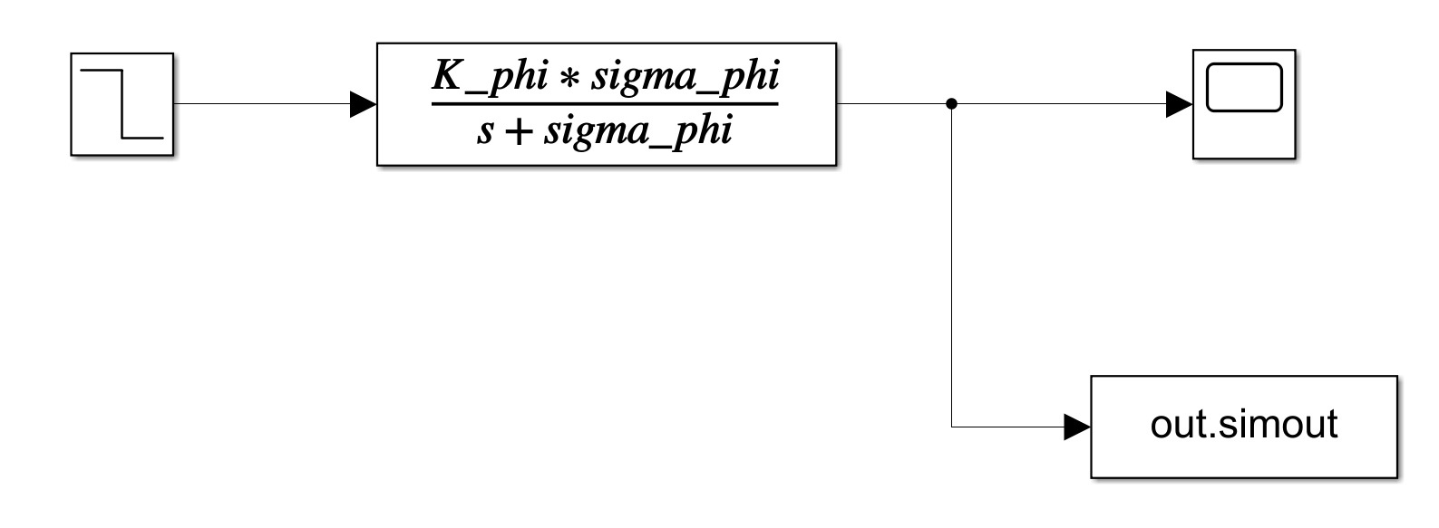
Figure 7: fullRobotRot.slx
For the robot rotation step experiment, each motor was given a voltage equal in magnitude but opposite in direction, as to rotate the robot in place as a constant velocity. The angle of the camera with respect to the x-axis was calculated and sampled. The Simulink model was tuned to fit the output to the experimental data. Figure 8 below shows both experimental and simulated responses.
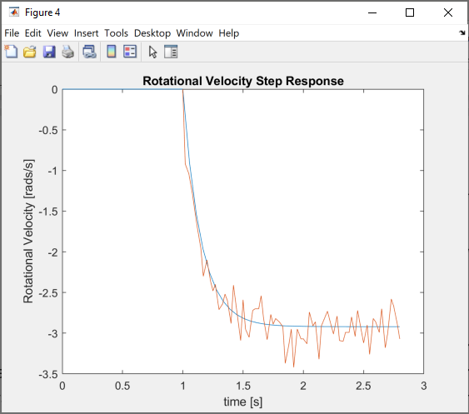
Figure 8: Rotational Velocity Step Response Results – Simulated and Experimental

Simulation 2: Angular Position Controllers
The control scheme used to drive the motors in Demo 1 worked as follows: the Arduino calculated the angular position required of each wheel to either drive forward or rotate in place. The error between actual angular position of each wheel and desired angular position of each wheel was fed to a PI controller that output V/deg, which was finally converted to a usable PWM input. Block diagrams for each motor’s controllers are shown below.

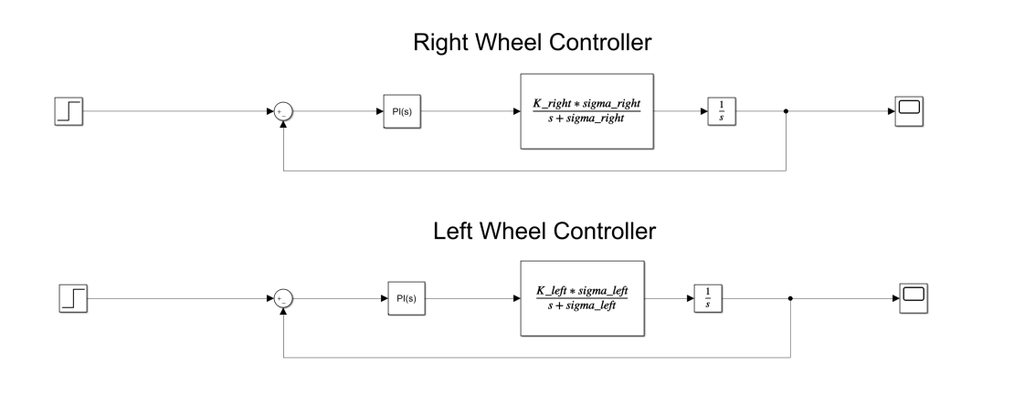
Figure 9: robotWheelControl.slx
The right wheel’s proportional gain was tuned to 1.867 V/deg and the integral gain was tuned to 0.0846 V/(deg*s). The left wheel’s proportional gain was tuned to 1.877 V/deg and the integral gain was tuned to 0.0851V/(deg*s). The following scope measurements, Figure 10, represent the right and left wheel control response to a step input of a desire angular position of 3.14.
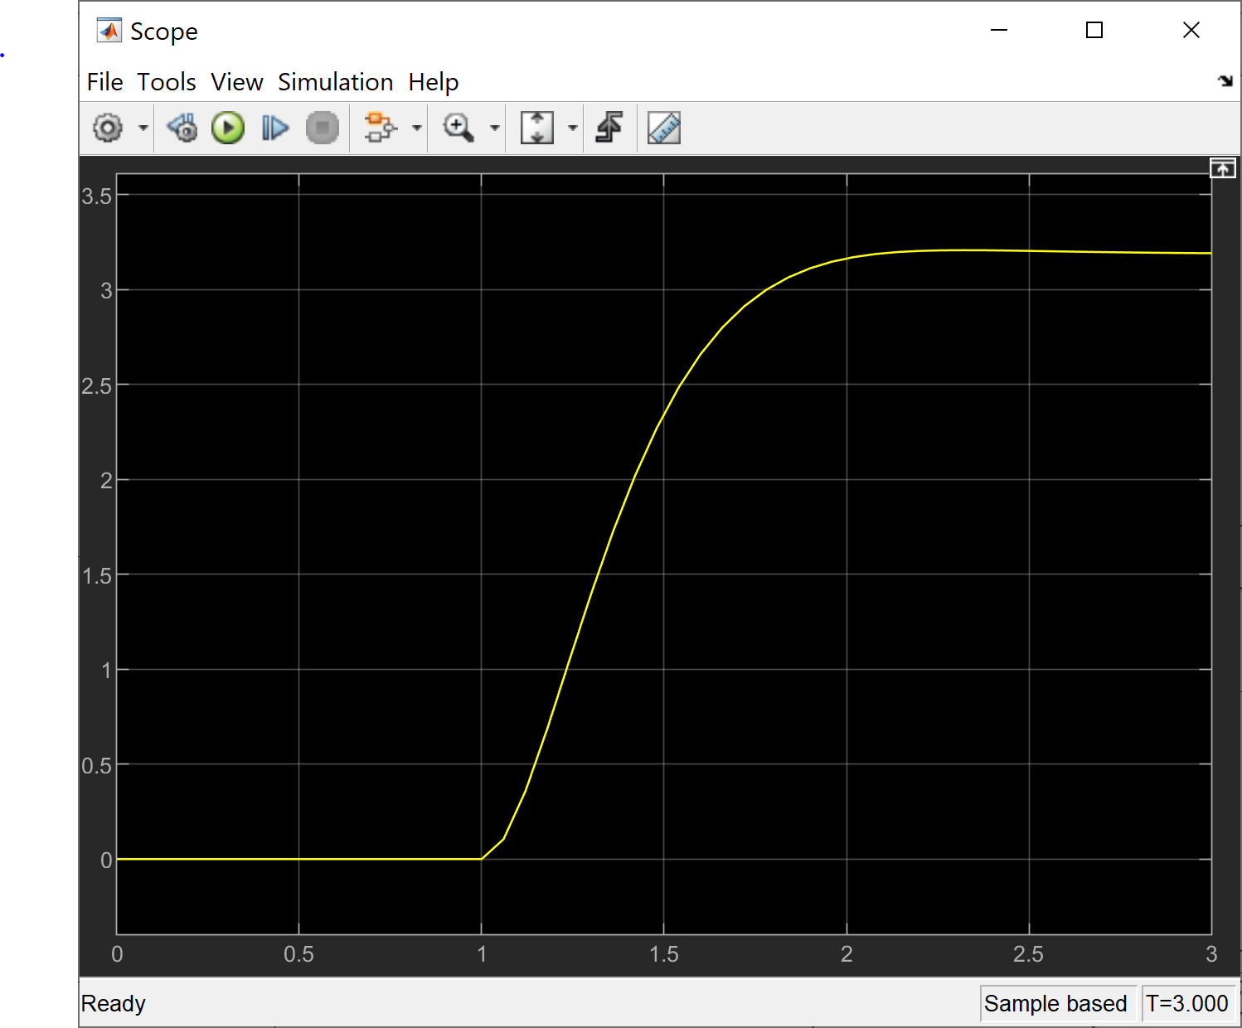
Figure 10: Left Wheel Input Control Response – Simulated
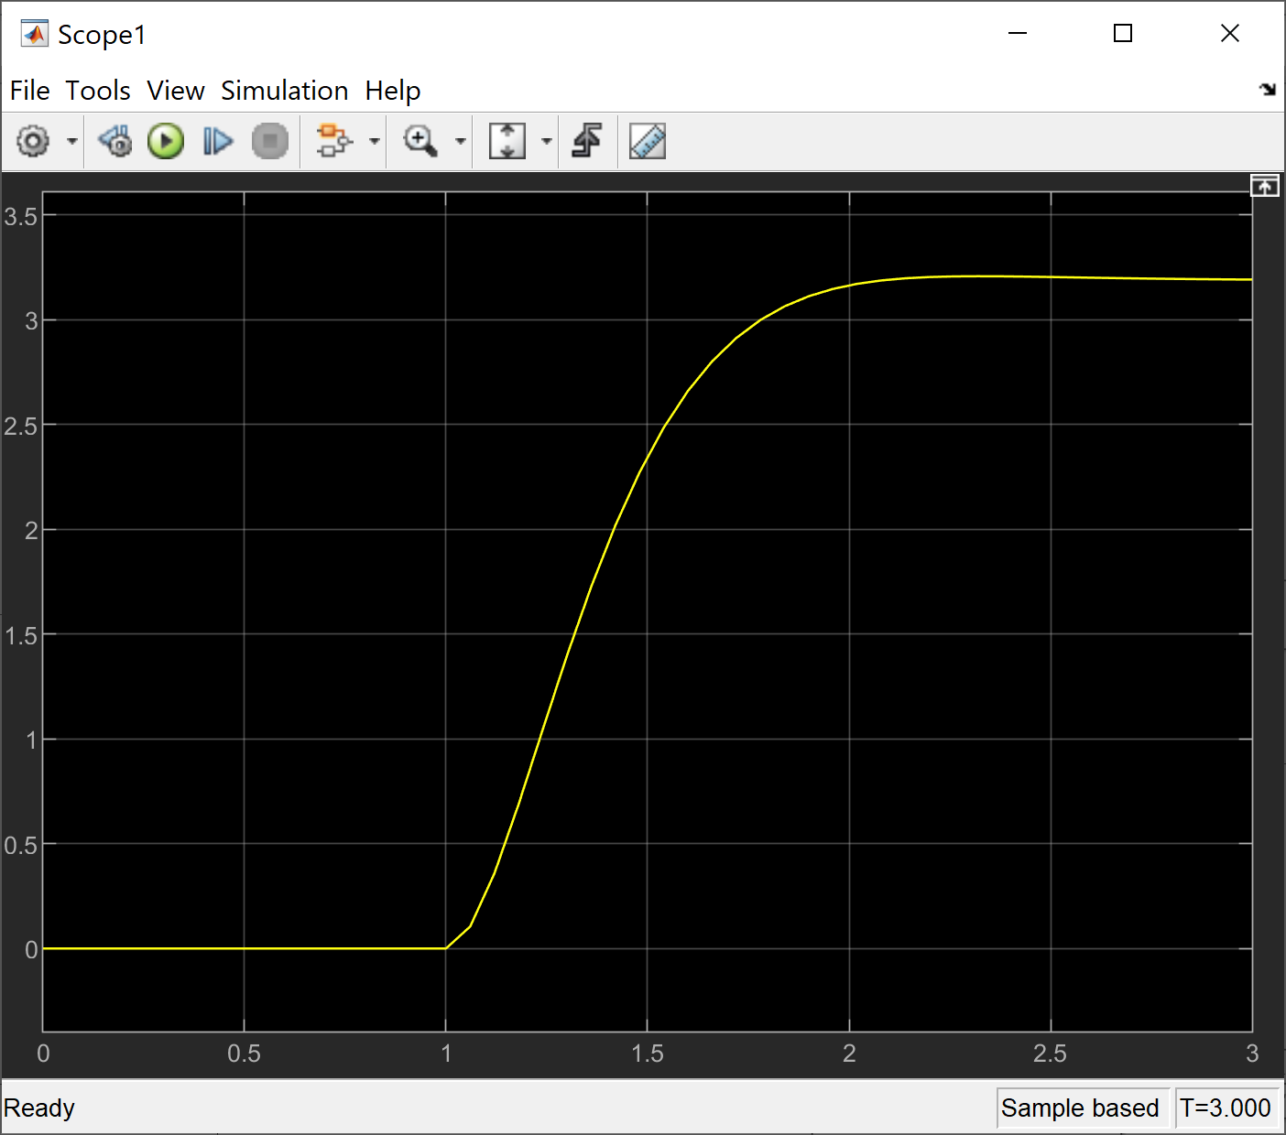
Figure 11: Right Wheel Input Control Response – Simulated
In implementation, these controller gains had to be significantly adjusted using trial and error. Additionally, this control scheme led to performance issues where the right wheel was able to spin faster than the left wheel and, therefore, making the robot curve when it should have driven in a straight line. Moving forward into Demo 2 and the Final Demo, the controller scheme will be changed to a controller that uses the robot’s (x,y) coordinates and Φ angle as feedback as opposed to angular position of each wheel. This new control scheme is discussed in the following section.

Simulation 3: Coordinate Controller
The control scheme that will be used in Demo 2 and the Final Demo will take in the x and y coordinates alongside the robot’s angular position Φ and outputs a PWM signal to each motor. The following block diagrams model this control scheme.
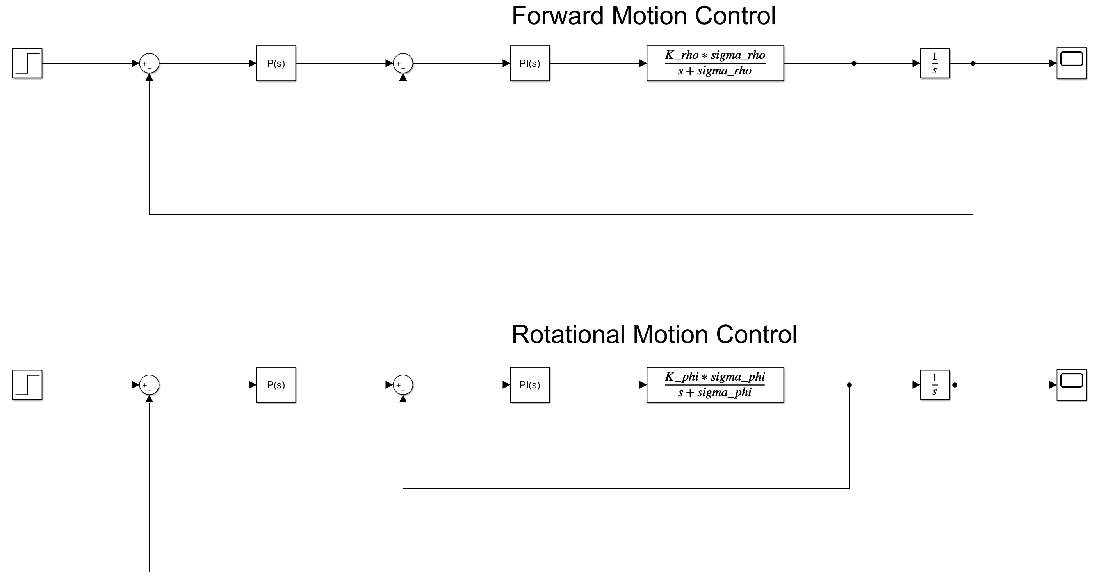
Figure 12: robotPIDController.slx
The MATLAB script outerLoopControllerDesign.m was used to produce a root locus plot that could be used to determine the outer loop proportional gain value. The respective plots for the forward motion control root locus and the rotational motion control root locus are shown below.
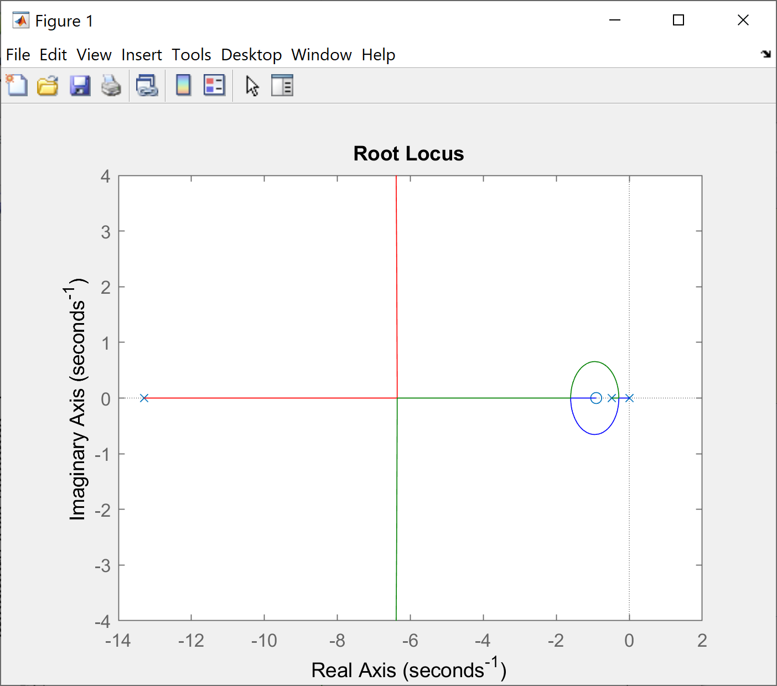
Figure 13: Forward Motion Root Locus Plot
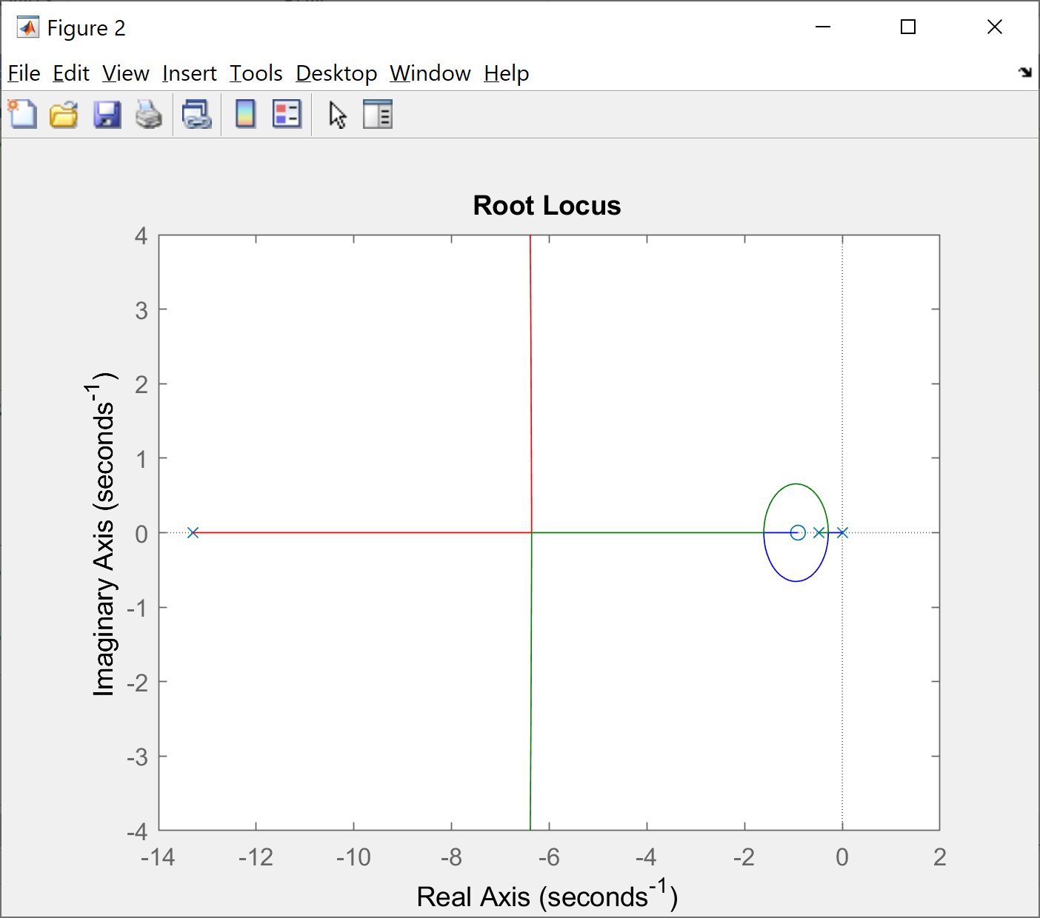
Figure 14: Rotational Motion Root Locus Plot
Using the root locus plots, the proportional gain of both feedback systems was chosen to be 4. The resulting output for forward motion control of the robot with an input of 10 inches is in the following scope.
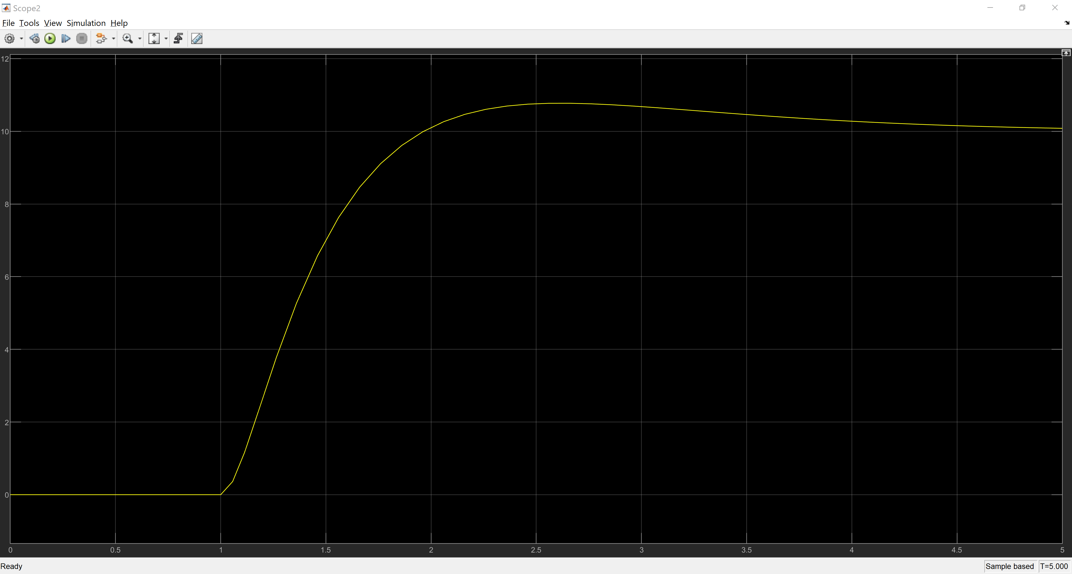
Figure 15: Closed Loop Forward Motion Control, Distance 10 inches
The resulting output of rotational motion control with an input of 6.28 radians is shown in the following scope.

